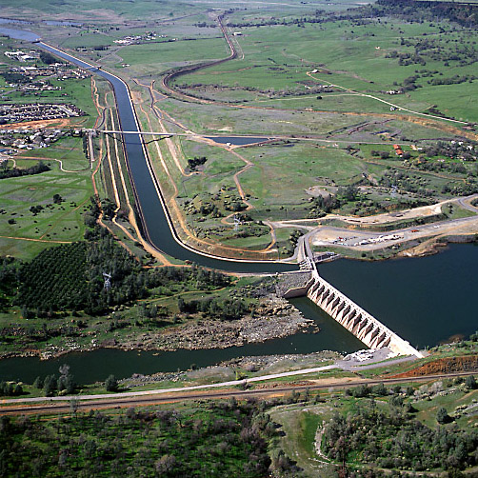

**STORAGE**

**HEADWORKS**

**Chapter IV**

**MODULE – IV : STORAGE HEADWORKS**

**STORAGE HEAD WORKS:** Types of dams – Site selection and Reservoir Planning – Forces acting on and causes of failure of a gravity dam – Elementary and practical profiles – Stability analysis – Single and multiple step methods of design – Grouting – Multipurpose projects.

**1. DEFINITION**

*A dam is a barrier constructed across a river or a natural stream to create a reservoir for impounding water, or to facilitate diversion of water from the river, or to retain debris flowing in the river along with water.*

**2. CLASSIFICATION OF DAMS**

Dams may be classified in different ways on the basis of their function, hydraulic design, material of construction and structural design.

1. **Classification Based on Function**

On the basis of function, dams may be classified in the following categories.

**(a) *Storage Dam or Impounding Dam*.** A storage dam is constructed to create a reservoir to store water during the period when the flow in the river is in excess of the demand, for utilisation later on during the period when the demand exceeds the flow in the river. The water stored in the reservoir so created may be used for various purposes such as irrigation, hydroelectric power generation, water supply etc.

**(b) *Detention Dam.*** A detention dam is primarily constructed to temporarily detain all or part of the flood waters of a river and to gradually release the stored water at controlled rates so that the entire region on the downstream side of the dam may be safeguarded against the possible damage due to floods. A detention dam may also be used as a storage dam. Similarly by suitable operation of the reservoir a storage dam may also be used as a detention dam.

***(c) Diversion Dam.*** A diversion dam is constructed for the purpose of diverting part or all of the water from a river into a conduit or a channel. Mostly for the purpose of diversion of water from a river into an irrigation canal a weir is constructed across a river which is known as diversion weir.

***(d) Coffer Dam.*** A coffer dam is a temporary dam constructed to exclude water from a specific area. Such a dam is invariably constructed on the upstream side of the site where actual dam is to be constructed so that the site for the constructional work is rendered dry. The coffer dam constructed in this case also behaves as a diversion dam.

***(e) Debris Dam.*** A debris dam is constructed to catch and retain debris such as sand, gravel, silt and drift wood flowing along with water in the river.

1. **Classification Based on Hydraulic Design**

On the basis of hydraulic design, dams may be classified as follows.

1. ***Ovedlow Dam or Overfall Dam.*** An overflow dam is constructed with a crest to permit the overflow of surplus water which cannot be retained in the reservoir. Usually dams are not designed as overflow dams for their entire length. Only some dams few metres in height have their entire length designed for overflow, which are mainly used for diversion of water and are known as diversion weirs.
2. ***Non-overflow Dam.*** A non-overflow dam is that for which water is not allowed to flow over its crest.

In most of the cases a part of the length of dam is designed as an overflow dam, while the rest is designed as non-overflow dam. In such cases the overflow section of a dam is called **spillway**. However, in some cases a non-overflow darn is not combined with an overflow dam, but it is provided with a different type of spillway.

1. **Classification Based on Material of Construction**

***Based on the material used for construction,*** the dams may be classified in the following categories.

1. **Rigid Dam.** A rigid dam is that which is constructed with rigid material such as masonry, concrete, steel or timber. Earlier stone masonry was commonly used for the construction of dams, but now-a-days it is almost totally replaced by concrete.

**Eg:** Bhakra dam (maximum height 226 m) which is concrete dam and Rana Pratapsagar dam (maximum height 53.96 m) which is a stone masonry dam, are the example of rigid dams in India.

A steel dam is made of steel plates supported on inclined struts and a timber dam is made of wooden planks supported on a wooden framework. The steel and timber dams are constructed only for very small heights and these are rarely constructed.

1. **Non- rigid Dam.** A non-rigid dam is that which is constructed with non-rigid material such as earth, tailings, rockfill etc. There are four types of non-rigid dams viz., earth dam, tailings dam, rockfill dam and rockfill composite dam. An earth dam (or earthen dam) is constructed with gravel, sand, silt and clay. A tailings dam is built from the waste or refuse obtained from mines (or mine tailings).

A rockfill darn consists of fragmental rock material supporting a water tight membrane on the upstream face. A rockfill composite dam consists of a rockfill on the downstream side and an earth fill on the upstream side.

All these four types of non-rigid dams are normally classified under the category of embankment dams.

In most of the cases an earth dam is provided with a concrete or stone masonry overflow or spillway section. Such a dam is known as composite dam.

Further in some cases a part of the length of a dam is constructed as earth dam and the rest is constructed as stone masonry dam (length of spillway portion being excluded). Such a darn is known as masonry-curer-earth dam.

Ex: Nagarjunasagar dam (maximum height 124.7 m) is an example of masonry-cum-earth dam in India.

1. **Classification Based on Structural Behaviour**

On the basis of the structural behaviour, dams may be classified in the following categories.

1. **Gravity Darn.** A gravity dam is a masonry or concrete dam which resists the forces exerted upon it by its own weight. Its cross-section is approximately triangular in shape. If a gravity dam is straight in plan it is known as straight gravity darn, while if it is curved in plan it is known as curved gravity dam.

A curved gravity dam (or arch-gravity dam) however, resists the forces exerted upon it both by gravity action and arch action. Further a gravity dam is also classified as solid gravity dam and hollow gravity dam.

A solid gravity dam has its entire body consisting of a solid mass of masonry or concrete. On the other hand a hollow gravity dam has hollow spaces left within the body of the dam. Most of the gravity dams constructed in India are straight solid gravity dams and **Bhakra dam** is an example of this type of dams.

1. **Arch Dam.** An arch dam is a curved masonry or concrete dam, convex upstream, which resists the forces exerted upon it, mainly by arch action.

**Ex:** Idduki dam which is double curvature (in plan) arch dam in concrete.

1. **Buttress Darn.** A buttress dam consists of a *water retaining sloping membrane* or deck on the upstream which is supported by a series of buttresses which are generally in the form of equally spaced triangular reinforced concrete or masonry walls or counterforts. The ***sloping membrane*** is usually reinforced concrete slab.

In some cases the upstream slab is replaced by multiple arches supported on ***buttresses*** or by flaring the upstream edge of the buttresses to span the distance between the buttresses. The former is known as *multiple arch buttress dam* and the later is known as *hulk head buttress dam or massive head buttress dam.* In general the structural behaviour of a buttress dam is similar to that of a gravity dam.

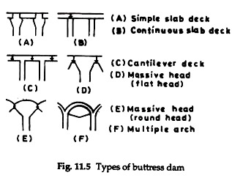

1. **Embankment Dam.** An embankment dam is a non-rigid dam, which resists the forces exerted upon it mainly by its shear strength. To some extent an embankment dam also resists the forces exerted upon it by gravity but its structural behaviour is different in many respects from that of a gravity dam and hence it cannot be included in the category of a gravity dam.

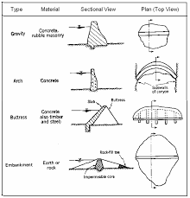

1. **Classification Based on Size**

The dams may be classified according to size by using the *hydraulic head* (from normal or annual average flood level on the downstream to the maximum water level) and the gross storage behind the dam as given below. The overall size classification for the dam would be greater of that indicated by either of the following two parameter:

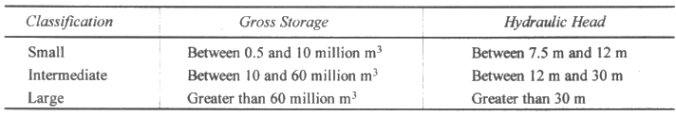

**3. FACTORS GOVERNING SELECTION OF TYPE OF DAM**

It is rare that for any given dam site only one type of dam is suitable. Thus except in the cases where the selection of the type of dam is obvious, it would be necessary to prepare preliminary designs and estimates for the several types of dams before one can get the best solution from the point of view of direct costs and all other factors. The various factors which affect the choice of the type of dam are described below.

1. **Topography—Valley Shape.** In general topography dictates the first choice of the type of dam and the most important factor in this respect is the *shape of valley or gorge*. The shapes of valleys normally found in nature may be broadly classified in three categories and for each of these a particular type of dam is generally suitable as indicated below.
2. A narrow V-shaped valley with sound rock in abutments has an arch dam as the first choice. However, for economic arch dam it is preferable to have the top width of the valley less than about four times its height.
3. A narrow or moderately wide U-shaped valley with sound rock foundation is best suited for gravity dam or buttress dam.
4. A wide valley with foundation of soil material to a considerable depth leaves no choice but an embankment dam.
5. **Geology and Foundation Conditions.** All the forces acting on dam including its weight are transmitted to the foundation. As such the foundation conditions at the dam site need to be thoroughly investigated. The foundation conditions will limit the choice of the type of dam to certain extent, though such limitations can frequently be modified. Foundation conditions depend upon the geological character and thickness of the strata, their inclination, permeability and relation to underlying strata, existing faults and fissures.

The common types of foundations generally encountered are discussed below.

1. **Good Rocky Foundations.** Good rocky foundations have high bearing capacity and offer high resistance to erosion and percolation. Therefore any type of dam can be built on such foundations. However, in this case the choice of the type of dam will be governed by economy of materials or overall cost. Sometimes seams and fractures are present in these rocks which will have to be sealed by grouting. Further disintegrated rock if any will have to be removed.
2. **Gravel and Coarse Sand Foundations.** Gravel and coarse sand foundations are unable to bear the load of high concrete gravity darns. As such these foundations are suitable only for earthfill, rocktill and low concrete gravity dams upto about 15 m height. Since through these foundations water may percolate at high rates, effective water cutoffs or seals will have to be provided.
3. **Silt and Fine Sand Foundations.** These foundations are suitable only for earthfill dams and low concrete gravity dams upto about 8 m height, and they are not suitable even for rockfill dams. In these foundations the main problems are settlement, the prevention of piping, excessive percolation' of water and protection of the foundation at the downstream toe from erosion.
4. **Clay Foundations.** There may be considerable settlement of the dam constructed on clay foundation, if the clay is unconsolidated and the moisture content is high. As such clay foundations ale ordinarily not suitable for the construction of concrete gravity dams and totally unsuitable for rockfill dams. However, earthfill dam may be constructed on clay foundations but these may also require special treatment to consolidate the foundation. Moreover, tests of the foundation material in its natural state are usually required to determine the consolidation characteristics of the material and its ability to support the superimposed loads.
5. **Nonuniform Foundations.** At several dam sites uniform foundations of any of the types described above are not found. As such if the dams are to be built at these sites, the same will have to be constructed on nonuniform foundations of rock and soft material. However, such unsatisfactory conditions of foundation can be overcome by adopting special designs or appropriate foundation treatments.
6. **Availability of Construction Materials.**

The choice of the type of dam also depends on the types of construction materials that may be available in sufficient quantity at or near the dam site. This is so because a dam constructed with locally available materials will be the most economical due to considerable reduction in the transportation costs for the construction materials. Thus availability of suitable aggregate viz , sand and gravel or crushed stone for concrete is a factor favourable to the constructions of a concrete dam. On the other hand if suitable soils are available, the choice may be for an earthfill dam.

1. **Spillway Size and Location.**

Spillway is a structure provided for a dam to pass surplus or flood water which cannot be contained in the reservoir. The size and type of spillway are mainly decided by the magnitude of the flood to be bye-passed and its location depends on the site conditions.

The choice of the type of dam is also affected by size, type and location of a spillway. Thus if a large spillway is required to be provided, then generally spillway and dam are combined into one structure, in which case a concrete dam with overflow and non-overflow sections may be adopted.

On the other hand if small spillway is required then even in narrow dam sites the choice may be in favour of earthfill or rockfill dams. An overflow type of spillway in general favours the selection of a concrete or masonry dam while other types of spillways generally have earthtill or rockfill dams as the first choice.

However, nowadays overflow concrete or masonry spillways are also provided for embankment dams, though several problems are associated with such designs. The spillway may be located either away from the dam or within the limits of the dam.

When a spillway is located at a site away from the dam, then the entire dam can be non-overflow type and the choice may include rigid as well as non-rigid dams. In some of these cases a separate spillway channel may be required to be excavated, then an earthfill dam may be selected to utilize the excavated material.

On the other hand if the spillway is to be located within the limits of the dam then the choice of the type of dam will have be such that it can include an overflow type of spillway. In this case the spillway can be placed so as to occupy only a portion of the main river channel and the remainder could be non-overflow dam of earth, rock or concrete.

1. **Environmental Considerations.**

The environmental considerations can also have a major influence on the choice of the type of dam. The selection of the type of dam, its dimensions and location of spillway and other appurtenances should be such that there are no adverse effects on the environment and as far as possible maximum protection is provided for the environment.

For example a particular river might be having scenic and/or recreational quality for most of its length, which will be spoiled completely if a high dam is constructed and a big reservoir is created in which considerable land will be submerged.

A possible alternative in this case may be to construct a low diversion dam at the same site and divert water to an off-stream reservoir created at a suitable site away from the river so that environmental qualities of the river are preserved. Thus it would be necessary to consider one or more alternative designs and select the one which would provide maximum environmental protection.

1. **Earthquake Zone.**

If a dam is to be constructed in an area that is subject to earthquake shocks then the selection of the type of dam should be such that it is able to resist the earthquake shocks without damage.

Although by including the provisions for the added loading due to earthquake in the design any type of dam may be adopted in these areas, but earthfill and concrete gravity dams are the best suited types of dams in this respect.

1. **Cost.**

The overall cost of construction of dam and the cost of subsequent maintenance would often become the deciding factors in the choice of the type of dam. The cost of construction of dam is affected by the availability and price of construction materials and labour, while the cost of subsequent maintenance mainly depends on the nature of the construction materials.

Thus if the choice is between gravity and buttress dams, then though the concrete required for a buttress dam is much less as compared to that in gravity dam, the cost of special type of form work and reinforcement required for a buttress darn should also be taken into consideration to arrive at the final decision.

Similarly the in'tial cost of construction of an earthfill dam may be less but the cost of subsequent maintenance would be more than that of a concrete dam and hence this factor would require consideration in the final selection of the type of dam.

1. **General Considerations.**

The choice of the type of dam also depends on various other considerations such as problem of diverting the stream flow during construction, availability of labour and equipment, inaccessibility of sites, limitation of outlet works and cost of protection from spillway discharges.

Unless a dam is so small that it can be constructed in a single dry season there must be some means of diverting the stream flow during construction usually through a tunnel in the abutment that can be closed after construction.

However, at any dam site if diversion of stream flow is not possible then earthfill dam cannot be constructed and the choice will be in favour of masonry or concrete dam. This is so because it is possible to pass flood flows through a partially constructed masonry or concrete dam during construction without causing much damage to the dam section. The type of the dam may also be selected to utilize the locally available labour.

Nagarjunasagar dam in India was built as a stone masonry dam mainly due to the consideration of providing employment for local labour.

**4. SELECTION OF SITE FOR A DAM**

The selection of a suitable site for the construction of a dam depends on various factors which are briefly described below.

(1) Suitable foundations should be available at the darn site. It is however possible to improve the foundation conditions by adopting appropriate foundation treatments.

(2) For economy it is necessary that the length of the dam should be as small as possible and for a given height it should store large volume of water. It therefore, follows, that the river valley at the dam site should be as narrow as possible and it should open out upstream to create a reservoir with as far as possible large storage capacity. Often the dam is located on the downstream of the confluence of two rivers. so that advantage of both the valleys to provide larger storage capacity is available.

(3) As far as possible the dam should be located on high ground as compared to the river basin. This will reduce the cost and facilitate drainage of the dam section.

The topographical and geological regional maps prepared by various Government organisations are available which are extremely useful for the reconnaissance work. The reconnaissance work involves visiting all available sites which have a possibility of being utilized and gathering information which will be useful for planning the detailed surveys and investigations.

The information collected during reconnaissance may include geological data obtained without any kind of subsurface exploration, approximate estimation of stream flow data, storage capacity and head available etc. Further at the time of reconnaissance the approximate spillway requirement and also possible site for its location should be determined. Information should also be collected about the main types of existing environmental resources and changes likely to take place after the construction of the dam and creation of reservoir.

In the course of preliminary investigation sufficiently precise data is collected at several sites selected during reconnaissance to determine the most economical and suitable site among these.

The preliminary investigation usually requires the following items.

1. A not too precise site survey with the resulting topographic site map.
2. Some investigation of the overburden.
3. A few borings, say from 6 to 50, according to the size of the dam.
4. A preliminary geologic investigation and corresponding report.
5. Investigation of available construction materials, such as earth and gravel and concrete aggregates.
6. Determination of public utilities such as roads, railroads, telephone and telegraph lines, pipe lines and power plants which might be affected by the construction of dam.
7. Hydrologic studies.
8. Determination of the quantity of silt carried by the stream.
9. Checking of high-water marks for their use in determining spillway capacity requirements.

After the preliminary investigations at the several possible dam sites have been made and office studies and estimates for each of them completed, one of the several sites is selected for final, precise investigation. The final investigation involves the following principal items.

(i) A sufficiently precise site survey and preparation of topographical maps to serve all the purposes of design and construction of dam.

(ii) Accomplishment of necessary borings, test pits, sub-surface explorations, geologic studies and tests on the materials in foundation and in the proposed borrow lands.

(iii) Determination of the type of dam to be used.

(iv) Planning the foundation treatment on the basis of sub-surface investigation.

(v) Demarcation of lands for the sites of structures and for other necessary purposes.

(vi) Determination of the extent of land, villages etc., which would be submerged in the reservoir and the arrangements for rehabilitation for the residents of that area.

(vii) Determination of the extent and character of relocation of railroads and public highways necessary on account of the creation of reservoir.

(viii) Obtaining sufficient information for an accurate estimate of cost.

(ix) Determination of the final location of the dam, construction equipment, colonies for labour and other staff members, coffer dams, construction highways and railroads, as well as the probable source of materials of construction and all other information needful to the construction engineer.

(x) Obtaining all necessary information affecting the design of the dam.

It may however be mentioned that there is no distinct line of demarcation between the preliminary and the final investigations of dam site and often one blends into the other.

**5. FORCES ACTING ON A GRAVITY DAM**

The various forces acting on a gravity dam are as follows.

1. Water pressure.
2. Weight of the dam.
3. Uplift pressure.
4. Earthquake (or Seismic) forces.
5. Silt pressure.
6. Wave pressure.
7. Ice pressure.
8. Wind pressure.

Each of these forces are described below.

1. **Water Pressure.** Water pressure is the force exerted by the water stored in the reservoir on the upstream face of the dam. It can be calculated by the law of hydrostatics according to which in a static mass of liquid the pressure intensity varies linearly with the depth of liquid and it acts normal to the surface in contact with the liquid.

For the non-overflow and the overflow (or spillway) sections of the darn water pressure may be calculated as indicated below.

*Non-overflow Section* For a dam with upstream, face vertical the water pressure is equal to the total pressure on the plane AB as shown in Fig. 4.2 (a). For plane AB, triangle 1-2-3 represents the pressure distribution diagram, with pressure intensity equal to zero at the water surface and equal to wH at the base, where w is the specific weight of water and H is the depth of water. The water pressure P, per unit length of the dam is equal to the area of triangle 1-2-3 and is thus given by

P = ½ wH2

Which acts horizontally at H/3 from base of the dam.

When the upstream face of the dam is either inclined or is partly vertical and partly inclined, as shon in fig 4.2(b), the water pressure can be conveniently calculated in terms of its horizontal and vertical components. The horizontal components Ph of the water pressure per unit length of the da, is equal to the total pressure on the palne AD and this is given by equation as

PH= ½ wH2

Which also acts horizontally at H/3 from base of the dam.

The vertical component Pv, of the water pressure per unit length of the dam is given by

Pv = the weight of water contained in the prism ABCD of the unit length

Which acts vertically downward at the centre of gravity of the area ABCD

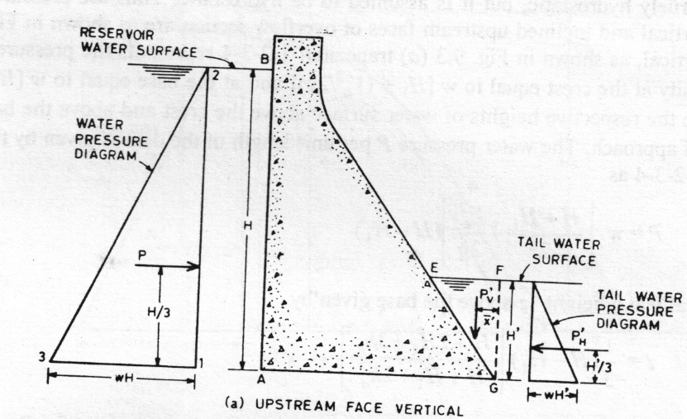

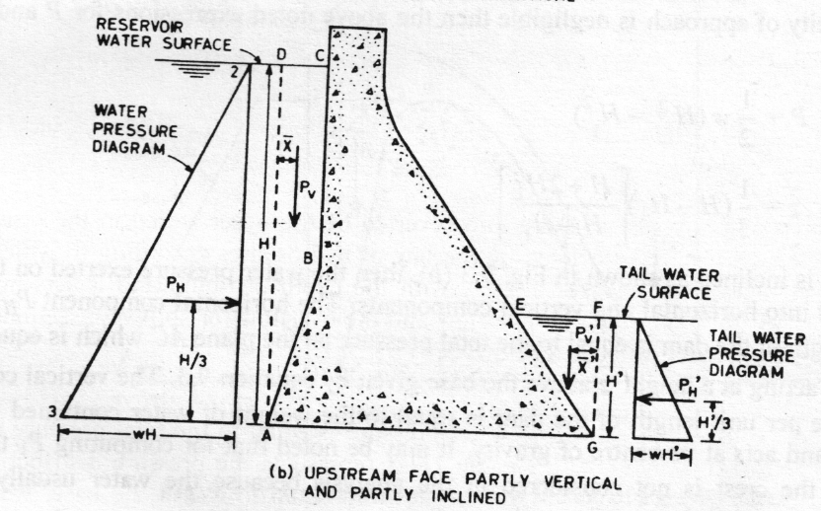

**(2) Weight of the Dam.**

The weight per unit length of the dam is given by the product of the area of cross-section of the dam and the specific weight of the construction material via., concrete or stone masonry and it acts vertically downwards at the centre of gravity of the section.

For the sake of convenience the entire cross-section of the dam may be divided into smaller sections of simple geometrical shapes such as triangles, rectangles etc., and the weight of each of these acting at its centre of gravity may be considered.

For a gravity dam the weight of the dam is the main stabilising force, and hence the construction material should be as heavy as possible.

The specific weight of concrete and masonry depends considerably on the various materials that go to make them. Thus in order to obtain heavier concrete/masonry, the coarse aggregate/stones should have greater specific gravity.

Further coarse aggregate/stones of larger size should be used to reduce voids and thus to obtain dense concrete/masonry. For preliminary designs, the specific weight of concrete and stone masonry may be taken as 23 544 N/m1 or 23.544 kN/m3 or [2400 kg(I)/m3] and 22 563 N/m3 or 22.563 kN/m3 or [2300 kg(f)/m3] respectively.

**(3) Uplift Pressure.**

Uplift pressure is the force exerted by water penetrating through the pores, cracks and seams within the body of the dam, at the contact between the dam and its foundation, and within the foundation. It acts vertically upwards at any horizontal section of the dam as well as its foundation and hence it causes a reduction in the effective weight of the portion of the structure lying above this section.

The computation of uplift pressure involves the consideration of two constituent elements viz., (i) the area on which the uplift pressure acts and

(ii) the intensity of the uplift pressure at various points.

The **percentage of the area** on which the uplift pressure acts is defined as the **area factor**. The value of area factor for concrete has been determined experimentally by several investigators, a value of area factor ranging from 1/3 to 2/3, i.e., only one-third to two-thirds of the area may be considered as effective area over which the uplift pressure acts. For both concrete and rock, the value of area factor is nearly equal to unity.

As such the present practice followed in the seign of ams is that the uplift pressure is assumed to act over 100 percent of the area within the body of the dam as well as it s foundation.

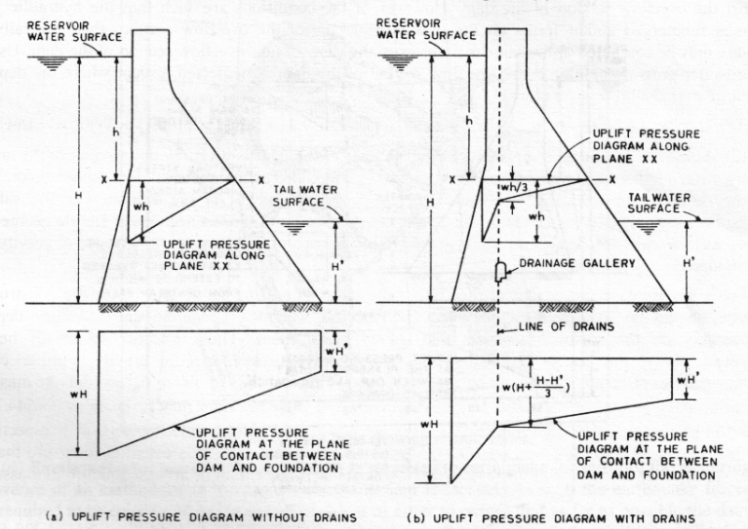

The intensity factor is defined as the ration of the actual intensity of the uplift pressure developed when the cutoff wall is provided to the intensity of uplift pressure which would be developed without cutoff wall.

**4. Earthquake (or seismic) forces**

A dam is subjected to earthquake (or seismic) forces during the occurrence of an earthquake in the region where the dam is located. As such the earthquake forces are also required to be considered in the design of a dam in order to ensure that as far as possible the dam can withstand these forces without any damage being caused to it.

Earthquake sets the earth's crust into a state of vibration due to the generation of a series of waves in the soil mass. These waves originate from a point or a small area called **focus** around which the disturbances are centred and it is located deep into the earth's crust. The corresponding point on the surface of the earth lying vertically above the point of disturbance or focus is called **epicentre**. At the time of the occurrence of an earthquake the first type of waves that are released from the focus are **primary waves** which are **compression waves.** These waves alternately compress the soil and release it and have higher velocity but smaller amplitude and wave-length. Next in series are released the **secondary** waves which are **shear or transverse waves** having smaller velocity but greater amplitude and wave-length. The secondary waves cause more damage as compared to the primary waves. The secondary waves are followed by other waves which are in general a combination of primary and secondary waves. All these waves impart a momentary acceleration to the earth's crust and thus cause its movement in the direction in which the wave is travelling at that instant. Since the dam acts as one with the foundation, the earthquake acceleration imparted to the foundation is also transmitted to the dam. The earthquake forces acting on a dam obviously depend on the earthquake acceleration imparted to it which may be determined as indicated below.

The earthquake acceleration is usually designated as a fraction of g the acceleration due to gravity and it is expressed as **αg**, where a is known as a **seismic coefficient**. The seismic coefficient depends on various **factors** such as intensity of the earthquake, the part or zone of the country in which the dam is located, the elasticity of the material of the dam and its foundation etc. For the purpose of determining the value of the seismic coefficient which may be adopted in the design of a dam, India has been divided into four seismic zones i.e., Zone II to Zone V depending upon the severity of the earthquakes which may occur in the zones. The value of the seismic coefficient gradually increases with a minimum value for zone II to a maximum value for zone V. Further as indicated in IS: 1893-1984 the value of the seismic coefficient a may be determined by one of the following **two methods**.

1. Seismic coefficient method
2. Response spectrum method

In seismic coefficient method **α = β I αo**

In response spectrum method **α = β I Fo (So/g)**

Where, β = Soil – Foundation system factor, the value of which for dams is taken as 1.0

I = Importance factor, the value of which for dams is taken as 2.0.

αo = basic seismic coeff., the value of which for each of the five seismic zones

Fo = seismic zone factor for avrg. Acceleration spectra

(So/g) = Avrg. Acceleration coeff.

**(5) Silt Pressure.**

Practically all streams carry silt along with water which during floods may be in enormous quantity. When a dam is constructed on a stream the silt carried by it will get deposited against the upstream face of the dam and it will exert a pressure on the dam. Silt is treated as a saturated cohesionless soil having full uplift and whose value of the angle of internal friction is not materially changed on account of submergence. Further, the experiments have indicated that in a submerged fill the silt pressure exerted on a dam is in addition to the water pressure and that the silt pressure on the dam is reduced due to the reduction in the weight of the silt by submergence. For determining the silt pressure Rankine's formula may be used according to which the total silt pressure Psh acting per unit length of the dam with its upstream face vertical is given as follows :

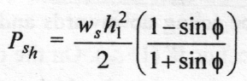

where, ws = submerged sp.wt. of silt in N/m3.

h1 = the depth of silt deposited in m, and

φ = angle of internal friction of silt.

**(6) Wave Pressure.**

Wind blowing over the water surface in the reservoir exerts a drag on the surface due to which ripples and waves are formed. The impact of these waves produces a pressure on the upper portion of the dam. The magnitude of the wave pressure mainly depends on the dimensions of the waves which in turn depend on the extent and configuration of the water surface, the velocity of wind and the depth of water in the reservoir. The most significant dimension of a wave is the height of the wave in terms of which the wave pressure exerted on the dam can be expressed.

Earlier as recommended in IS: 6512-1972. for determining the wave height Moliter's formula was used which is as follows:

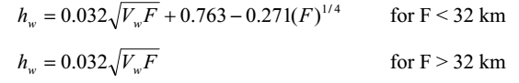

where Vw= wind velocity in km/hr and F= fetch length of reservoir in km.

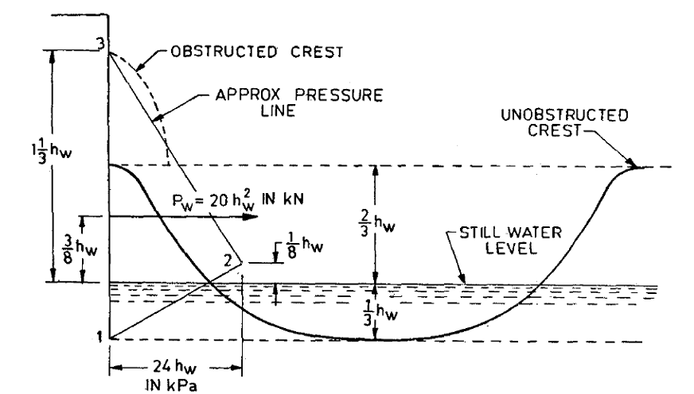

Fig. Wave configuration and wave pressure on gravity dam

**7. Ice pressure :** Ice pressure is exerted on a dam by a sheet of ice formed on the entire water surface of the reservoir when it is subjected to contraction and expansion with change in temperature. Ice pressure it may be provided for at the rate of **250 kPa** applied to the face of dam over the anticipated area of contact of ice with the face of dam.

**8. Wind pressure:**

Wind pressure does exist but is seldom a significant factor in the design of a dam. Wind loads may, therefore, be ignored. However, the superstructure of dams carrying very large sluice gates may be subjected to an appreciable amount of wing pressure. As such in the design of a superstructure of a dam wind pressure may be considered as the rate of **1 to 1.5 kN/m2** over the area exposed to the wind.

**6. MIDDLE THIRD RULE – STRESSES AT FOUNDATION**

As shown in Fig. let ∑V be the sum of all the vertical forces and ∑H be the sum of all the horizontal forces acting on a darn above the base and R be the resultant of all the forces. For the dam to be in static equilibrium the resultant R. must be balanced by an equal and opposite reaction of the foundation, consisting of the total vertical reaction equal to IV and the total horizontal shear or friction equal to F.H. Further let 0 be the centroid of the area of the base of the dam and (F be the point of intersection of the resultant with the base. The base of the dam is thus subjected to eccentric loading and hence the vertical (or normal) stress at any point on the base may be obtained as a combination of direct stress and bending stress by the following expression

C:\Users\NAMBI HARISH\Documents\Scanned Documents\pics\1.PNG

where,

σy = vertical (or normal) stress at the base

∑V = sum of all the vertical forces, including uplift but excluding foundation reaction

A = area of the base

I = moment of inertia of the area of the base about an axis passing through its centroid and parallel to the length of the dam

x = distance from the centroid of the area of the base to the point at which the stress is determined and

e = distance between the centroid of the area of the base and the point of intersection of the resultant with the base, or eccentricity of loading.

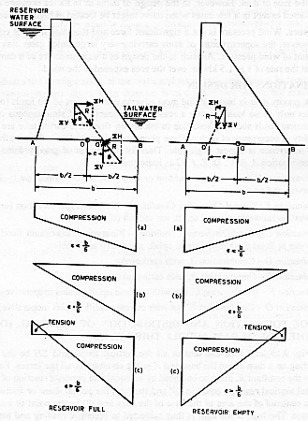

The direct stress at every point on the base is compressive, but the nature of the bending stress depends on the location of the point O’. Thus for the reservoir full condition the point O’ lies between O and B, corresponding to which the bending stress is compressive for any point between O and B and is tensile for any point between 0 and A. As such for the reservoir MI condition in equation is positive sign is to be used for all the points between O and B and negative sign is to be used for all the points between O and A.

On the other hand for the reservoir empty condition the point O' lies between O and A and hence the bending stress is compressive for any point between O and A and is tensile for any point between O and B. Accordingly for the reservoir empty condition in equation will be positive sign is to be used for all the points between O and A and negative sign is to be used for all the points between O and B.

The equation may also be used to obtain the distribution of vertical (or normal) stress at any horizontal section of the dam, in which case the values of the various terms in the equation are considered for the part of the dam lying above the section.

For a straight gravity dam of base width b, if unit length is considered then the base is a rectangle of length b and width 1 m. The centroid of the base is at the mid-point between the heel and the toe of the dam. Also A = b. and I = (b3/12). Substituting these values in equation, gives



In equation ∑V thus represents the sum of all the vertical forces acting per unit length of the dam. Further in this case for the toe and heel of the dam since x = b/2, the vertical (or normal) stress at these points may be obtained for reservoir full and empty conditions as indicated below.

For reservoir full,

At toe,



At heel,



For reservoir empty,

At toe,

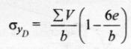

At heel,



**Note:** it thus follows that if no tension is to be produced at any point on the base of the dam the distance between the centre of the base and the point at which the line of action of the resultant cuts the base should be less than or equal to b/6 i.e., **e ≤ b/6.**

**7. MODES OF FAILURE OF DAM – STABILITY REQUIREMENTS**

A gravity dam must be designed to resist its failure in all the possible ways with ample factor of safety.

The various ways in which a gravity dam may fail are as follows :

1. Overturning.
2. Sliding.
3. Overstressing.
4. **Overturning.** A dam would overturn about its toe, or about the downstream edge of any horizontal section, if the resultant of all the forces acting on the entire dam or on the part of the dam lying above the horizontal section, passes outside the base or the horizontal section of the dam. However, such a condition does not arise in actual practice, but a dam may overturn if the toe or the downstream edge of a horizontal section of a dam fails by crushing due to excessive compressive stresses, so that the effective width of the base or that of the horizontal section would be reduced to cause the resultant to pass outside the dam section. It thus follows that the failure of a dam by overturning would be preceded by the failure due to excessive compression. which in turn would result if the resultant passes appreciably outside the middle third of the base or that of any horizontal section of the dam. Moreover, if the resultant passes outside the middle third, tensile stress would occur at the heel or at the upstream edge of the dam at any horizontal section. Due to tension a horizontal crack may occur which would result in increasing the uplift pressure as shown in Fig and thus in reducing the stabilising force for the dam. As such a gravity dam may be considered **safe against overturning** if the criterion of ***no tension at any point in the dam*** is satisfied.

Furthermore another safety criterion usually adopted is to compute a ***factor of safety against overturning*** which is defined as ***the ratio of the stabilizing moments to the overturning moments about the toe of the dam for the reservoir full condition and about the heel of the dam for the reservoir empty condition***, i.e..

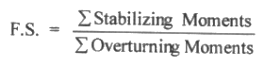

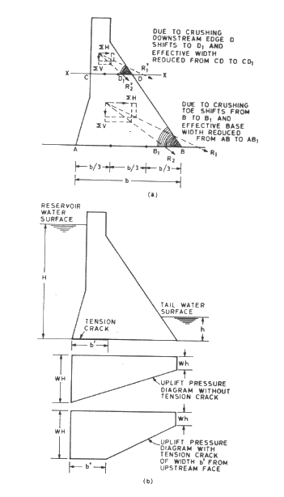

1. Overturning of gravity dam (b) Effect of Tension crack on uplift pressure

FOS against overturning varies from **1.5 to 2.5 and should not be less than 1.5.**

**(2) Sliding.** The horizontal forces acting on dam tend to slide the entire dam at its base or a part of the dam lying above any horizontal section over the lower part. This tendency to slide is resisted by the sliding resistance developed at the surface of sliding or plane of contact. The resistance to sliding is ***due to friction at the surface of sliding and cohesion inherent in the materials at contact*** viz., concrete (or masonry) and foundation rock. For the stability of a dam against sliding the minimum total available resistance to sliding must exceed the total magnitude of the forces tending to cause sliding along any horizontal section of the dam by a safe margin. Thus for a dam a factor of safety against sliding may be considered which is defined as the ratio of the forces resisting sliding to the forces tending to cause sliding and it may be computed in either of the following two ways. If the sliding is resisted by friction only then the force resisting the sliding is equal to the product of the coefficient of friction and the vertical reaction which is equal to the sum of all the vertical forces including uplift. The factor of safety against sliding at any horizontal section of the dam is then given by the equation:

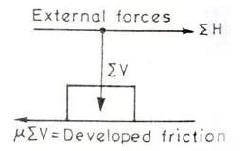

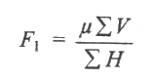

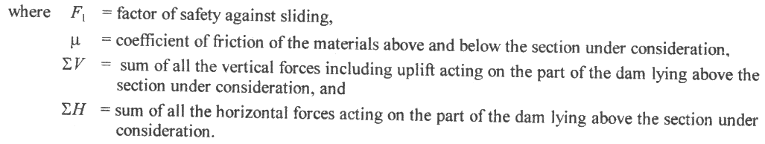

If θ is the angle between the vertical and he resultant of all the forces, then tanθ is known as **sliding factor**, and since tan θ = (∑V/∑H), then the above equation may also be expressed as



The value of μ for concrete on concrete (or masonry on masonry) and for concrete or masonry on good rcok foundation varies from 0.6 to 0.75

If the sliding is resited by friction and cohesion or shear strength of the concrete (or masonry) or foundation rock, then the factor of safety against sliding is known as **shear friction factor.**

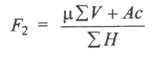



The factor of safety against sliding is then given by the following equation

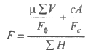

**(3) Overstressing.** A dam may fail if any of its part is overstressed and hence the stresses in any part of the dam must not exceed the allowable working stress for the concrete or masonry. Further in order to ensure the safety of a dam against its failure due to overstressing the strength of the concrete or masonry must exceed the stresses anticipated in any part of the dam by a safe margin which according to IS: 6512-1984 is as indicated below.

**(i) Compressive strength.** The compressive strength of concrete and masonry is determined and it shall conform to the following requirements:

***(a) Concrete.*** The strength of concrete should satisfy early load and construction requirements and at the age of one year the compressive strength should be four times the maximum computed stress in the dam or 14000 kN/m2, whichever is more. Further the allowable working stress in any part of the dam shall also not exceed 7000 kN/m2.

**(b) Masonry.** The strength of masonry should satisfy early load and construction requirements and at the age of one year the compressive strength should be five times the maximum computed stress in the dam or 12500 kN/m2. whichever is more.

If the stresses at the heel and toe are excessive they can be brought within permissible limits by providing fillets with slopes one horizontal to two vertical at the heel and two horizontal to one vertical at the toe. The height of these fillets above heel and toe are given by the following expressions.

For heel



For toe



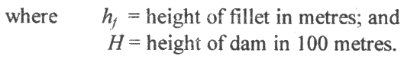

**(ii) Tensile strength.** Although concrete and masonry are known to possess some tensile strength, its quantitative evaluation is uncertain and difficult. Moreover, construction joints can be planes of weakness against tensile strength. Further due to tension, cracks may be developed which have significant adverse effects on the structural behaviour of the dam. As such no tensile stress is permitted at the upstream face of the dam for load combination under normal operating condition. However, nominal tensile stresses may be permitted in the case of other load combinations but their values should not exceed the permissible values.

**8. ELEMENTARY PROFILE OF A GRAVITY DAM**

If a gravity dam is subjected to only water pressure, uplift pressure and its self weight, then the stability conditions can be satisfied by a right angled triangular section having zero width at the water surface in the reservoir where water pressure is zero and a base width b at the bottom where the water pressure is maximum. The right angled triangular section of a dam will also provide maximum possible stabilising force against overturning via: lout causing tension at any point in the base for the reservoir empty condition. This is so because when the reservoir is empty the only force acting on the dam is its self weight which acts at a distance of b/3 from the upstream face of the dam, and hence satisfies the middle third rule. The right angled triangular section of a dam is known as the elementary profile of gravity dam. The base width of the elementary profile of a dam for no tension at any point in the base of the dam as well as for no sliding of the dam may however be obtained as indicated below. Consider an elementary profile of a gravity dam of height H and base width b as shown in Fig. The various forces acting on the elementary profile per unit length of the dam are as follows.

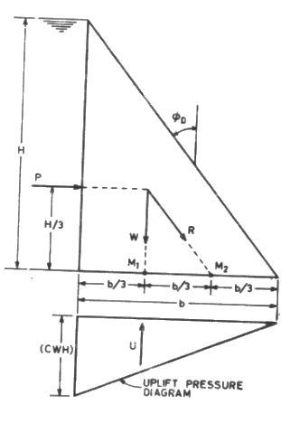

1. Weight of the dam (W)

W = ½*bH/sw , actig verticaaly downward at b/b from the heel,

where s = specific gravity of dam material

w = sp. Weight of water

1. Water pressure (P)

P = ½*wH2, acting horizontally at H/3 from the base,

1. Uplift pressure (U)

U = ½*b(cwH), acting verticallyupwards at b/3 from the heel,

where c = uplift pressure intensity factor.

**Base width of elementary profile for no-tension**

If R is the resultant of all the forces acting on the dam, then for no tension at any point in the base of the dam the resultant R must pass through the middle third of the base. Thus for the reservoir full condition the outer middle third point M2 is the limiting position of the point at which the resultant R may meet the base for no tension at any point in the base of the dam. As such assuming the resultant to pass through the outer middle third point M2, by taking moments of all the forces about M2 and equating the sum of the moments to zero (since the moment of R about M2 is zero), we get

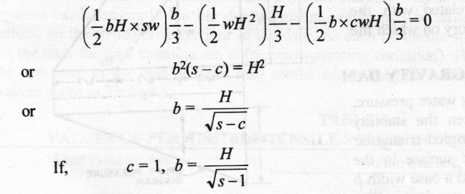

If uplift pressure is not considered then c = 0, we get

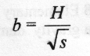

**Base width of elementary profile for no sliding**

For no sliding to occur the force resisting sliding must exceed the force causing sliding and in the limiting case these forces must be equal. Thus for an elementary profile if it is assumed that the sliding is resisted only by friction then the force resisting sliding is equal to µ(W — U); the force causing sliding is equal to P and in the limiting case, we have

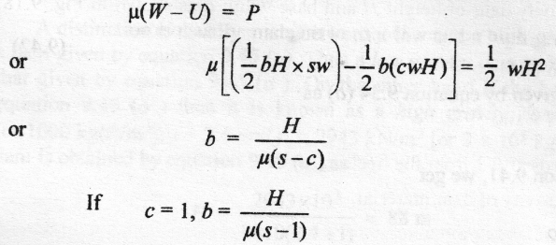

If uplift pressure is not considered then c = 0, we get

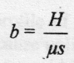

**10. LIMITING HEIGHT OF ELEMENTARY PROFILE OF GRAVITY DAM**

High and Low Gravity Dams For a dam having elementary profile the principal stress at the toe is given by equation as

σ1D = wH (s-c +1)

which shows that the value of σ1D varies only with H, as all the other terms are constant for any dam. In order to avoid failure of the dam due to crushing the value of σ1D should not exceed the allowable working stress *f* for the dam material and in the limiting case

f = σ1D = wH (s - c + 1)

from which the height H is given by



Thus above equation gives the maximum height which may be provided for a dam having elementary profile without exceeding the allowable working stress for the dam material.

**11. PRACTICAL PROFILE OF GRAVITY DAM**

The elementary profile discussed before is not possible from the practical point of view as the dam requires:

1. Roadway at the top

2. Additional load due to roadway top

3. Free Board (F.B.)

Hence the practical profile will be different from the theoretical profile. Due to the provision of the above three, the resultant will act outside the outer middle third, and tension at the heel and compression at the toe will occur. To eliminate these tension and compression, some extra concrete will be essential in the upstream face. A practical profile is shown in Figure.

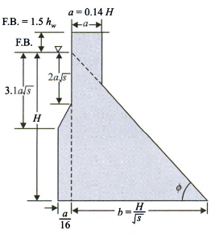

In Figure, free board (F.B.) is taken to be equal to 1.5 hw or 3 to 4 per cent of height of the dam. Here hw is the height of wave that is produced on the reservoir surface due to wind. The top width a is recommended by Creager to be 14 per cent of water height H which may be increased for other practical purposes like road widening, etc. The vertical distance upstream from water surface is equal to 2a. Other dimensions are shown in the figure. However, it is better to slightly increase the base width for stability purpose. Further study on preliminary and ideal section or profile of gravity dam is reported by Congleton and Sakania.

**12. METHODS OF DESIGN OF GRAVITY DAMS**

The various methods used for the design of gravity dams are as follows.

(1) Stability Analysis Method

(2) Zone Method of Determination of Profile of a Dam.

**(1) Stability Analysis Method.** In this method a trial section of the dam is first assumed on the basis of the previous designs, experience, configuration of valley, etc. The stability of the assumed section is then checked at the foundation level as well as at other levels. The various methods used for stability analysis are:

(i) Gravity method;

(ii) Trial load twist method;

(iii) Experimental method;

(iv) Slab analogy method;

(v) Lattice analogy method;

(vi) Finite element method.

These methods are briefly described below.

1. **Gravity method.** In this method the dam is considered to be composed of a series of vertical cantilevers independent of each other and the load acting on the dam is transferred to the foundation through cantilever action. For the sake of convenience a cantilever of unit length contained between two vertical planes normal to the axis of the dam is considered above the deepest foundation level and its stability is checked against all the possible modes of failure, at the base of the dam as well as at various horizontal sections above the base. If necessary the assumed dam section is modified and when a section satisfying the stability requirements is obtained the same is adopted for the entire dam.
2. **Trial load twist method.** If a dam is considered to be made up of a series of vertical cantilevers, then each cantilever from the centre of the dam towards the abutment will be shorter than the preceding one. Consequently due to water pressure each cantilever will be deflected less than the preceding one and more than the succeeding one. If the transverse joints between the adjacent cantilever blocks are keyed and either grouted or not grouted the movement of each cantilever will be restrained by the adjacent ones. The longer cantilever will tend to pull the adjacent shorter cantilever forward and the shorter cantilever will tend to hold it back. This interaction between the adjacent cantilever elements causes torsional moment or twist, which materially affects the manner in which the load due to water pressure is distributed between the cantilever elements in the dam. This changes the stress distribution from that found by the ordinary gravity analysis in which these effects are neglected.

In the trial load twist method, the dam is assumed to be divided into vertical cantilever elements and horizontal beam elements each of which occupies the entire volume of the dam. As the structural behaviour of a dam with joints keyed but not grouted is different from the one with joints keyed and grouted, each of these cases is dealt with separately.

*(A) Joints keyed but not grouted.* If the transverse joints between the adjacent cantilever blocks are only keyed but not grouted then the horizontal beams will behave as shear beams (i.e., beams capable of taking only shear and not the bending moment) and the horizontal elements will be subjected to twisting in the horizontal as well as vertical planes. Thus in this case the entire dam may be assumed to be made up of the following two structural systems.

(a) Cantilever structure

(b) Twisted structure.

The load acting on the dam due to water pressure is divided between the cantilever structure and the twisted structure in such a manner that the computed deflection for any point in the dam, considered as a point in the cantilever structure will be identical with its computed deflection, considered as a point in the twisted structure. The division of loading which will cause identical deflections at any point in the dam, considered in each of the two structural systems is found by successive trials. The process is repeated for all the points in the dam. The stresses are then computed from the forces and moments thus known.

*(B) Joints keyed and grouted.* If the transverse joints between the adjacent cantilevers are keyed and grouted then the entire dam will become a monolithic structure. Thus in this case the horizontal beams will be capable of taking bending moment in addition to shear, and hence an additional structure designated as beam structure is introduced for resistance to bending in the horizontal elements. The entire dam in this case may therefore he assumed to be made up of the following three structural systems.

(a) Cantilever structure

(b) Twisted structure

(c) Beam structure.

The load acting on the dam due to water pressure is now divided between these three structural systems in such a manner that the computed deflections are identical for any point in the dam considered in each of the three structural systems. The division of loading which will cause identical deflections at any point in the dam considered in each of the three structural systems is found by successive trials. The process is repeated for all the points in the dam. The stresses are then computed from the forces and moments thus known.

1. **Experimental methods.** The experimental methods may be classified as

(a) Direct method and

(b) Indirect method

***(a) Direct Method*** In this method either two dimensional or three dimensional geometrically similar models, which are the exact replica of the prototype dam, are made of elastic materials. In a two dimensional model a portion of the dam between two vertical planes normal to the axis is considered, while in a three dimensional model complete valley is considered. The model is located in similar manner as the prototype. The model is then acted upon by various pressures proportional to those of the prototype. In order to simulate the high water pressure acing on the prototype, a liquid of high specific gravity such as mercury may be used or the effect may be obtained by the jetting action of water. The deflections occurring at various points of the model are measured and from the correlation developed between the model and the prototype for these stress and deflection, the stresses for the prototype can be obtained. This method has been found to be quite useful for the analysis of high dams.

***(b) Indirect method****.* Under the indirect methods photoelastic model analysis and the methods of magnetic and electrical analogy are usually considered. In the case of photoelastic model analysis, a model of a dam is made of elastic, transparent, isotropic material which is free from initial or residual stresses. Some of the materials which have been successfully used for such models are bakelite, celluloid, gelatin and glass. The model is then proportionately loaded and the stresses developed in it arc determined by means of the visible optical effects which are produced by passing polarized light through the model. The effects of stress in a photoelastic model are made visible by means of an optical instrument known as photoelastic polariscope. From the stresses determined in the model the stresses in the prototype can be predicted. However, the studies employing photoelastic models are usually limited to conditions of plain stress or strain and for determining the regions of stress concentration.

1. **Slab analogy method.** The slab analogy method is based on the mathematical analogy between the distribution of stresses in a dam section and the deflections of a slab of similar shape by forces and moments around its edges. The slab has the same shape as a cantilever section including a large block of the foundation. The edges of the slab are bent into a form which corresponds to the stresses at the surface of the dam structure. The analysis is made by dividing the analogous slab into horizontal and vertical beams which are brought into slope and deflection agreement by trial loads. The curvatures in the slab are then proportional to the shears in the dam structure and consequently the moments in the horizontal and vertical beams are proportional to the stresses in the vertical and horizontal directions respectively. It is however a very laborious method.
2. **Lattice analogy method.** In the lattice analogy method the dam is considered as though it were a slice or plate of a unit thickness which in turn is simulated in size and shape by a lattice network composed of interconnected elemental square frames, each diagonally connected at the corners. The solution in this case involves the adjustment of the lattice by a systematic relaxation of restraints at the joints. When the adjustment of the lattice to remove restraint has been completed, the strains are deduced from relative displacements between successive joints and from these the stresses may be computed.
3. **Finite element method**. The finite element method can be used to analyse the structural behaviour of high gravity dams. In this method the dam and its foundation may be divided into elementary, contiguous triangles and the elastic properties of each may be analysed and linear simultaneous equations formulated for each nodal point. The solution of these equations would give the stresses and deflections due to a given system of loads.

**(2) Zone Method of Determination of Profile of a Dam.** The zone method of design of dam is also known as ***multiple step method or step by step method.*** In this method the dam section is considered to be divided into a number of zones as shown in Fig. and starting from the top of the dam each zone is designed in accordance with stability requirements as indicated below.

**Zone I.** It is that portion of the dam which begins from the top of the dam and extends upto the maximum water surface, or if there is ice, upto the bottom of the ice sheet. Both upstream and downstream faces of this zone are vertical. If there is no ice, the height of Zone I is fixed by the desired freeboard requirements and the width is determined by practical consideration such as minimum roadway required or economy for the entire dam section. However, when ice pressure occurs, the quantity of concrete or masonry provided in Zone I must have sufficient weight to prevent the portion 1-2-3-4 from sliding.

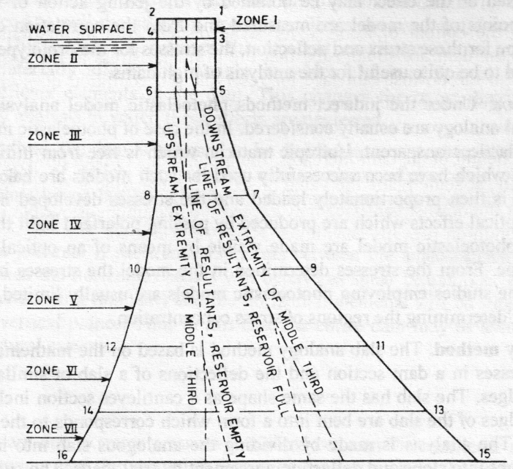

**Zone II.** For some distance below the bottom of Zone 1 the resultants for reservoir full and empty conditions lie well within the middle third, as the width of the top is always greater than necessary to conform to middle third rule. Hence the width same as at the top of the dam may be continued until at some plane 5-6 the resultant for reservoir full condition intersects this plane just at the downstream extremity of the middle third. The portion of the dam between the bottom of Zone I and the plane 5-6 constitutes Zone II. Therefore both upstream and downstream faces of Zone II are also vertical.

**Zone III.** Below the bottom of Zone II the downstream face of the dam will have to be made inclined in order to conform to middle third rule for reservoir full condition. However, for reservoir empty condition the resultant still lies within the middle third and hence the upstream face may remain vertical until at some plane 7-8 the resultant for reservoir empty condition intersects this plane just at the upstream extremity of the middle third. The portion of the dam between planes 5-6 and 7-8, in which the dimensions are determined by middle third rule for reservoir full condition, constitutes Zone III.

**Zone IV.** Below the plane 7-8 the upstream face of the dam will also be required to be made inclined in order to conform to middle third rule for reservoir empty condition. For some distance below the plane 7-8 the inclinations of the upstream and the downstream faces of the dam may be so adjusted that the resultants for the reservoir full and empty conditions intersect each plane just at the extremities of the middle third. However, at some plane 9-10, for reservoir full condition the principal stress at the downstream face may reach the maximum allowable limit, which thus fixes the lower limit of Zone IV. Hence the portion of the dam between the planes 7-8 and 9-10 constitutes Zone IV.

**Zone V.** Below the plane 9-10 for some distance the inclination of the downstream face of the dam will have to be so adjusted that for the reservoir full condition the principal stress at this face does not exceed the maximum allowable limit. In this case the resultant for reservoir full condition intersects well within the middle third. On the other hand the inclination of the upstream face is so adjusted that for reservoir empty condition the resultant continues to intersect just at the upstream extremity of the middle third. However, at some plane 11-12 for reservoir empty condition the principal stress at the upstream face may reach the maximum allowable limit, which thus fixes the limit of Zone V. The portion of the dam between planes 9-10 and 11-12 thus constitutes Zone V.

**Zone VI.** Below the bottom of Zone V for some distance the inclinations of both upstream and downstream faces of the dam are so adjusted that the principal stress at the upstream face for reservoir empty condition and at the downstream face for reservoir full condition does not exceed the maximum allowable limit. The portion of the dam between planes 11-12 and 13-14, which may be designed according to these rules thus constitutes Zone VI.

**Zone VII** As the height of the dam increases, the inclinations of both upstream and downstream faces increase. Consequently, at some plane the value the principal stress at the downstream face may exceed the maximum allowable limit. The portion of the dam in which this condition prevails constitutes Zone VII. However, this zone should be eliminated by revision of the entire design.